**\*MOTOR:** generate power for the propeller rotation to raise Quadrotor.

**- Brush**

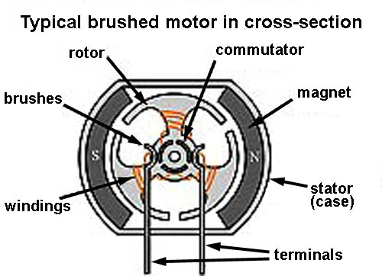

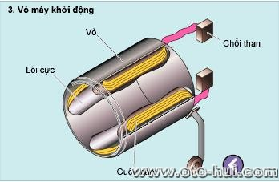

* **Brushless:**

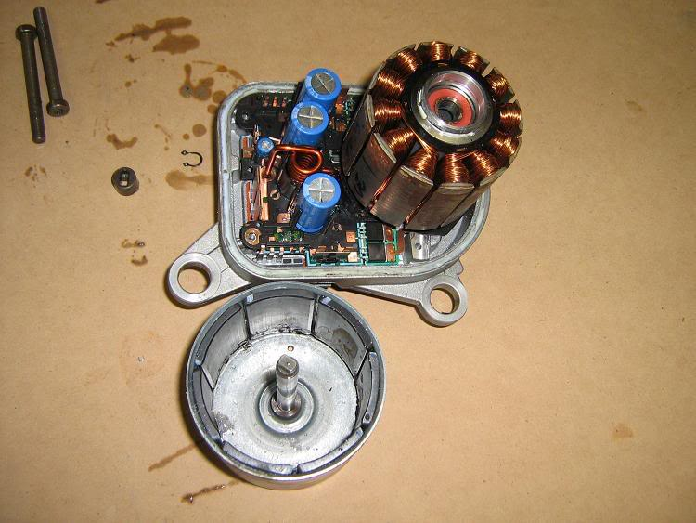

* **Brush vs Brushless:**
  + Brushless motors are often more efficient at converting electricity into mechanical power than brushed motors.
  + The maximum power that can be applied to a BL motor is exceptionally high, limited almost exclusively by heat, which can weaken the magnets.
  + more torque per watt (increased efficiency), increased reliability, reduced noise, longer lifetime (no brush and commutator erosion).

**Motor Himodel A2212-10T** **1400kv --- Price: 220k**

Link: <http://cholonhobby.com/may-bay-dieu-khien/Products/Detail/?tID=37&cID=648>

Detail:

* No. Of cells:2-3 Li-Poly
* Max. efficiency current:6-18A (>75%)
* No load current / 10 V:0,7 A
* Dimensions:27.5x30 mm
* Shaft diameter: 3.17 mm
* Weight:47 g
* Recommend prop : 8x4,9x5
* Thrust : 800g +

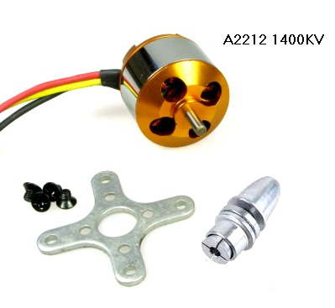

Explain:

* 1400kv or 1400RPM/V (RPM is revolutions per minute). Example:
  + Use power 1V for this: 1400 x 1 = 1400 revolutions/minute.
  + Use power 10V : 1400 x 10 = 14.000 revolutions/minute.
* Max. efficiency current: As the motor performance, the higher efficiency of energy is, the lower of energy loss. Will save battery for longer flight time.
* No load current / 10 V:0,7 A mean: if motor doesn’t work, power loss is 10V : 0,7A.
* Recommends Propeller : 8x4, 9x5:

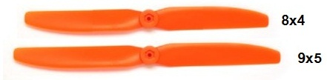

**\*ESC:** the electronic speed controller is a device that regulates the amount of power that goes to the electric motor.

**Esc HW 30A --- Price: 250k**

Link: <http://www.clbmohinh.com/forum/SKYTEAM-SHOPSALE-ESC-HW-30A_ESC-HIMODEL-10A_MOTOR-L%E1%BB%B0C-K%C3%89O-2KG-m562722.aspx>

Detail:

* Weight: 22g (including wire)
* Max Current: 35A (for ten seconds)
* BEC: 2A at 5V
* Input: 2 - 3 Lipo

Explain:

* BEC: Battery Eliminator Circuit, decrease input from battery(11V) to 5V for ESC use. Similar as Ampe.